Group ACS

Disease Management System

AED |12-10-2023

Prepared by: Group ACS

002859266 Chinmay Deshpande

002244396 Amey Satwe

002818444 Shreya Thakur

The success of key features and functionalities in the Disease Management System is confirmed in this study. Each component was carefully built to establish a comprehensive platform for smoothly managing hospital ecosystems, expediting login and registration processes, and assuring accurate patient progress tracking. Each component was executed flawlessly, resulting in a system that empowers both patients and administrators.

The platform's capabilities were clear from the start, with a quick registration procedure and good tracking of patient and doctor travels. Ecosystem administrators may now manage weak entities more effectively, while doctors, patients, NGOs, governments, insurance, lab administrators, pharmacy professionals, and treatment units can now explore and select courses depending on a variety of variables.

Furthermore, through evaluations, the system promotes intelligent data selection. When patients are evaluated, their data is released, and clinicians verify their diagnostics to ensure they are eligible. In conclusion, this ecosystem system has matured into a stable and effective platform, meeting its intended aims and so improving the educational experience for all parties involved.

# Problem Statement

The goal of the final project is to provide participants hands-on experience developing and implementing complex software systems. Students will take on roles such as functional architect, designer, programmer, inventor, and communicator. The goal is to build a digital platform that will serve as a communication system for experts and operational people across corporations, organizations, and individual users, encouraging collaboration for improved safety, service delivery, and affordability. The goal is to handle a multi-party problem by promoting cooperative efforts that outnumber individual contributions, resulting in a system in which the partnership's aggregate worth surpasses the sum of its parts.

# System Admin

The System Admin is the apex authority in the Disease Management System hierarchy, holding the highest rank. The System Admin, armed with unique login credentials, has complete control over crucial parts of the system's operation. This administrative position allows the System Admin to add and manage many entities that are required for the system to function properly. Patients, cities, pharmacies, general administrators, doctors, hospital administrators, treatment unit administrators, NGO administrators, insurance administrators, and lab administrators are among these entities. The System Admin is responsible for issuing credentials to each entity, underlining their key role in managing and directing the Disease Management System's entire environment.

Patients, as system entities, interact within this hierarchical framework enabled by the System Admin. The System Admin provides each patient with individual login credentials that provide secure access to the system. These credentials provide as a portal for patients to interact with the system while maintaining privacy and confidentiality. Patients can explore and use the Disease Management System's capabilities using their assigned credentials, allowing for smooth tracking of their progress and engagement in the collaborative healthcare ecosystem.

# Patient

The System Administrator provides login credentials to patients, granting them access to a variety of functionalities. Patients who have these credentials can seamlessly interact with the system, gaining access to essential features such as identifying nearby hospitals and patients, reviewing medical history, managing wallets including balance details, initiating requests to NGOs, and facilitating transactions related to insurance claims or purchases. This structured approach assures that patients can browse and exploit the system's numerous capabilities for comprehensive healthcare management.

# Doctor

Medical practitioners can access patient records, review previous interactions, and submit diagnoses from the doctor's dashboard, which is accessible via login credentials from the System Admin. This simple approach not only improves patient care but also highlights the System Administrator's critical role in maintaining secure and efficient healthcare interactions. The Disease Management System optimizes doctor collaboration by centralizing key processes, resulting in a more simplified and effective healthcare experience.

# Report

Reporting authorities obtain a full picture of critical healthcare parameters by accessing the Disease Management System's reporting dashboard via unique login credentials. They can quickly track the number of active patients, allowing them to provide real-time insights into the current health environment. Furthermore, the dashboard shows the overall number of hospitals and active doctors, as well as thorough information about each practitioner. This integrated platform enables authoritative bodies to make informed decisions, allocate resources wisely, and guarantee the healthcare system operates efficiently. The availability of key statistics encourages a data-driven approach, encouraging proactive steps and strengthening the reporter role in overseeing and managing healthcare services.

# Insurance

The Insurance Admin Dashboard within the Disease Management System is a critical platform for handling insurance-related transactions. With secure login credentials, insurance administrators may easily examine and approve insurance claims filed by patients. This simplified procedure guarantees that patient requests for coverage or purchases are met as soon as possible. The dashboard provides a consolidated view, allowing insurance administrators to easily review, validate, and facilitate transactions. This capability not only improves the efficiency of the insurance process, but it also adds to the overall efficacy of the healthcare ecosystem by assuring fast and correct processing of insurance-related concerns.

# Lab Admin

The Lab Admin Dashboard in the Disease Management System becomes the go-to platform for lab administrators who have secure access credentials. It provides a complete view from which they may see continuous talks between doctors and patients while learning about the diagnostic and treatment procedures. This user-friendly interface also gives real-time data on treatment progress, allowing lab supervisors to handle treatments more effectively. It also provides transparency by displaying the exact amount to be paid, so expediting financial processes. The Lab Admin Dashboard, which functions as a digital assistant, ensures that all stakeholders, from physicians to patients, are kept up to date, leading to a well-coordinated healthcare experience.

# NGO

The NGO Admin Dashboard is a compassionate place within the Disease Management System for administrators who have safe access credentials. This easy-to-use board provides access to specific patient information, promoting a better knowledge of individual requirements. Administrators may easily monitor financial balances, allowing them to make educated decisions and allocate resources. The option to select and sponsor medical bills is a unique feature, allowing NGOs to make a significant effect on patient treatment. As a result, the dashboard becomes a hub of empathy and support, offering a simplified platform for NGOs to actively promote health and well-being inside the healthcare ecosystem.

# Pharmacy

The Pharmacy Dashboard is a critical tool for pharmacists who have secure access credentials. This user-friendly technology generates a thorough medication list for each patient, assuring medication accuracy. Pharmacists may easily go through the patient-specific inventory and check the amount to be paid for the recommended medications. This user-friendly interface not only simplifies medicine delivery but also allows for more transparent invoicing procedures. It is a critical point in the healthcare ecosystem where pharmacists contribute to the entire patient care experience by assuring accurate and efficient management of pharmacological data.

# Treatment Unit

The Disease Management System's Treatment Unit Dashboard is a critical location for healthcare practitioners. It provides a comprehensive picture of patient information, including interactions, lab status, and treatment progress, with secure login credentials. This simplified platform improves communication and allows for well-informed decision-making within the treatment unit, resulting in a more coordinated and successful healthcare experience.

Architecture diagram:

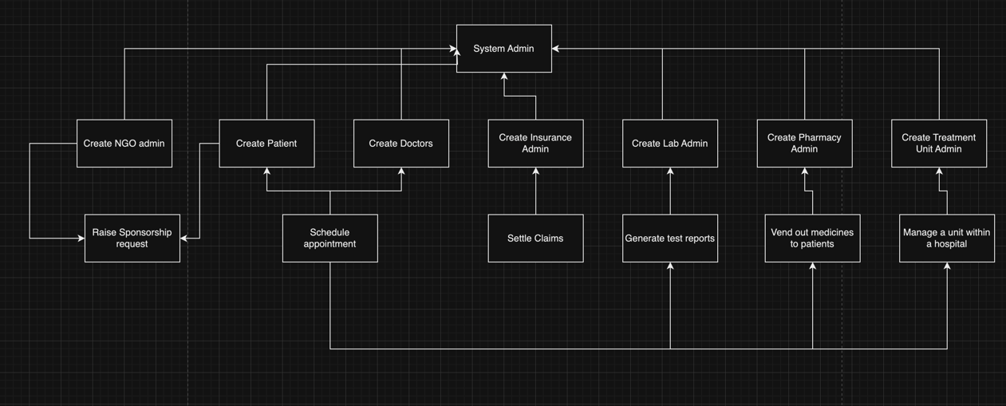

UML diagram:

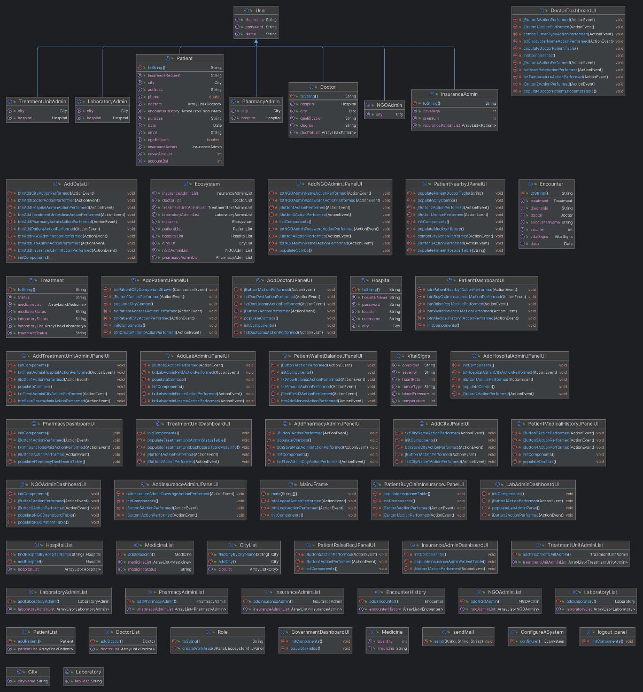

Dependencies

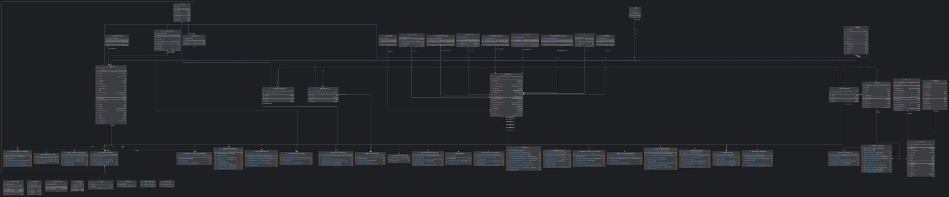

# Working

Login Panel

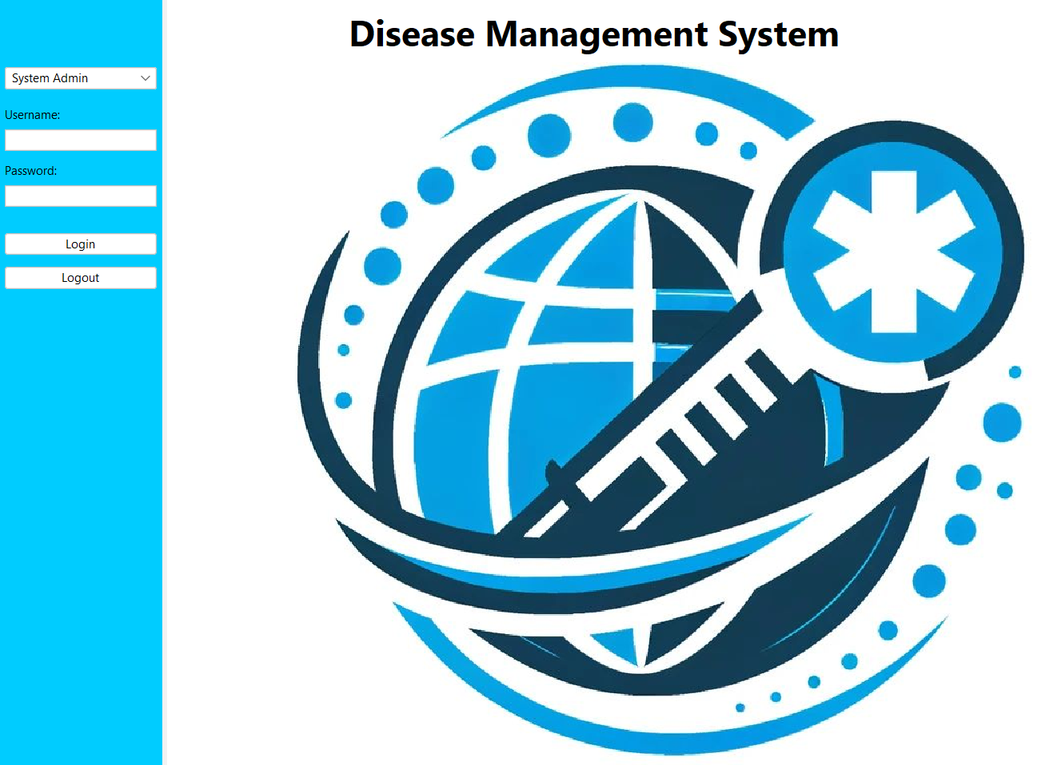

Landing Page for System Admin

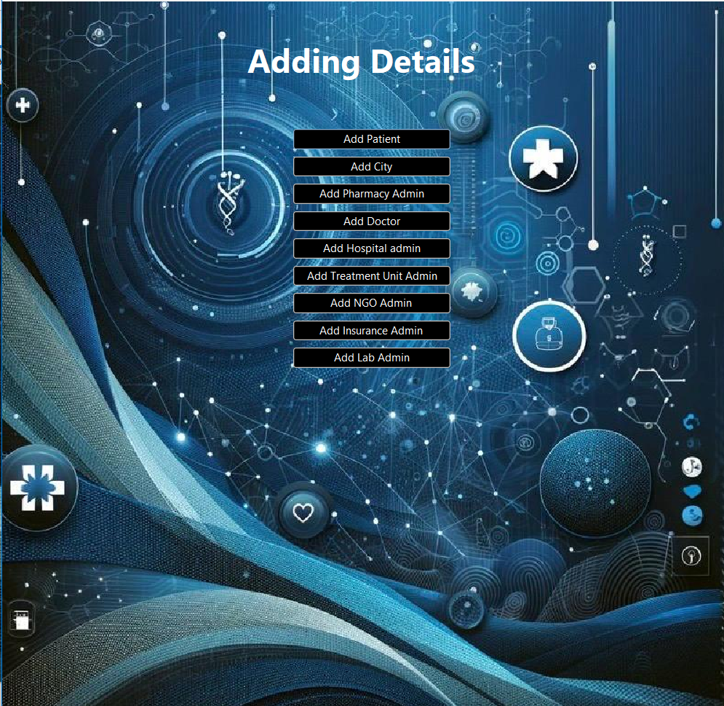

Patient and its Details

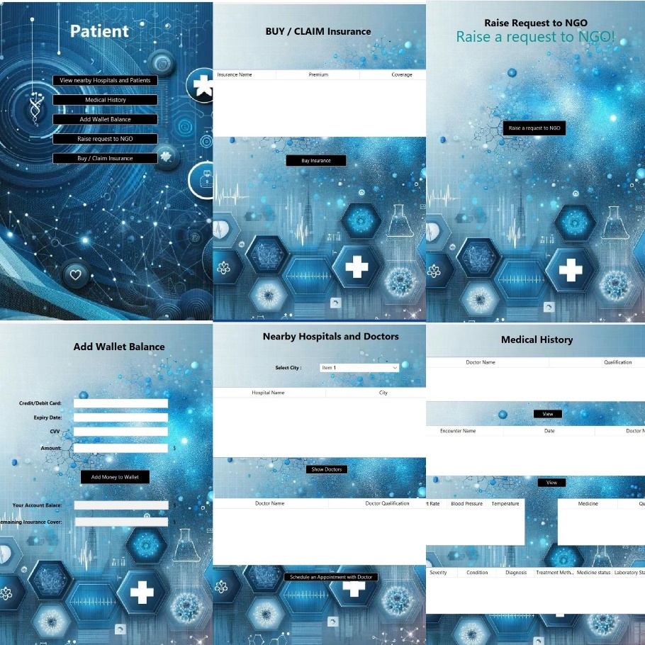

Dashboards: Doctor

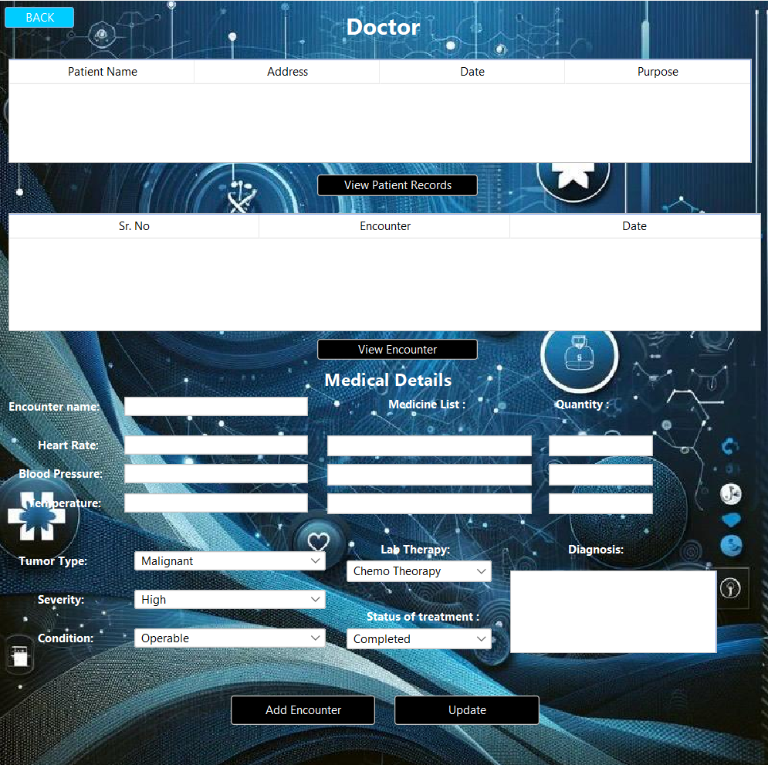

Dashboard Reporting

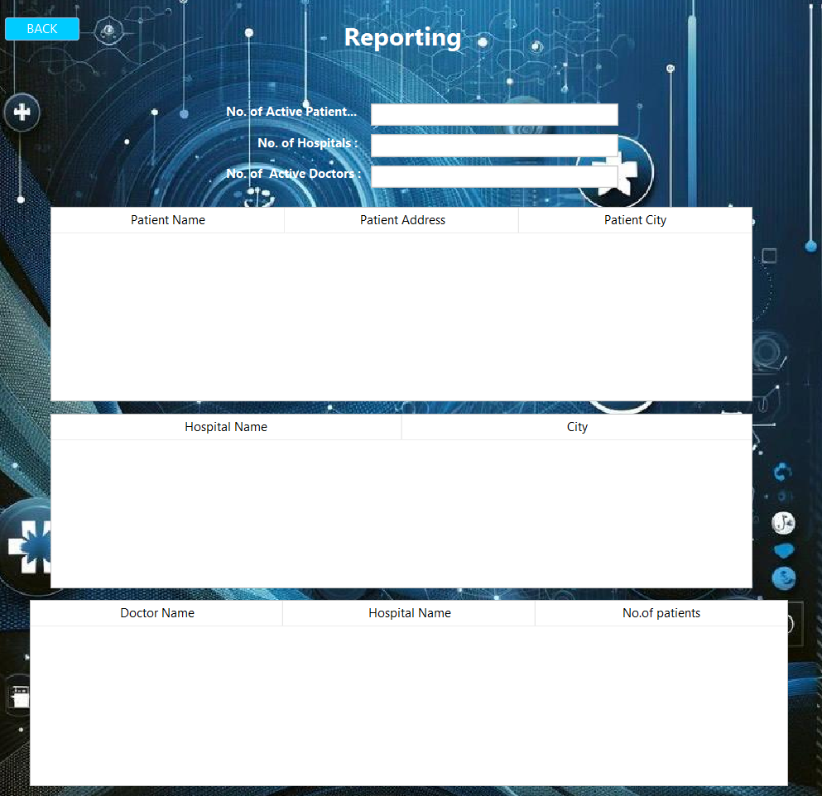

Dashboard Lab Admin

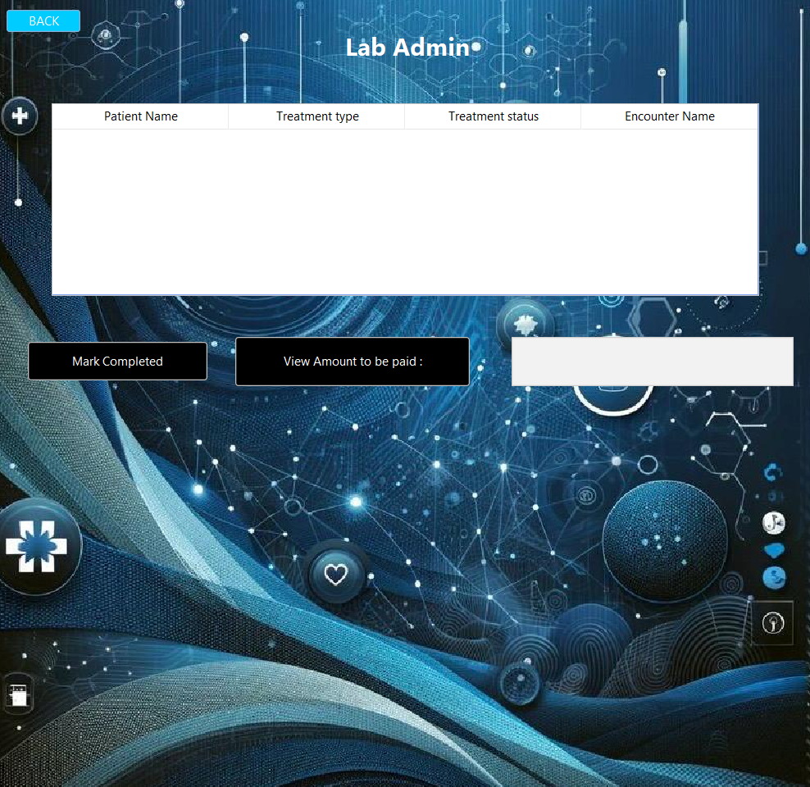

# Assessment

The Disease Management System has a strong hierarchical structure, with the System Admin at the top, each with their own login credentials. This administrator is responsible for adding and managing entities like as patients, cities, pharmacies, administrators, doctors, hospital administrators, treatment unit administrators, NGO administrators, insurance administrators, and lab administrators. Patient entities with System Admin privileges have access to a variety of capabilities such as identifying local hospitals and patients, viewing medical history, maintaining a digital wallet, and starting requests to NGOs or insurance procedures.

The Doctor Dashboard makes it easier for doctors to provide efficient patient care by allowing them to examine patient records, interactions, and diagnosis. The Government Dashboard gives a comprehensive picture of active patients, hospitals, and doctors. Insurance administrators use their dashboard to approve insurance claims or manage patient requests. Through their own dashboard, Lab Admins handle logs, treatment statuses, and payment data between doctors and patients. The NGO Admin Dashboard centralizes patient information and money balances, allowing non-profit organizations to sponsor medical costs. The Pharmacy Dashboard simplifies medication administration by presenting prescription medications and their related expenses. Finally, the Treatment Unit Dashboard provides healthcare providers with a full picture of patient information, allowing for better coordination and decision-making.

Overall, the Disease Management System improves healthcare operations by integrating numerous features seamlessly, providing complete patient care and effective communication among varied stakeholders.

# Conclusion

Ultimately, the Disease Management System is a huge improvement in healthcare operations, providing a flawlessly integrated platform with a wide range of capabilities. The hierarchical structure, lead by the System Admin, provides efficient entity administration and adds to the system's overall performance. Individuals may use the patient-centric features to gain access to essential information, interact with healthcare providers, and manage their medical history and finances. Through specialized dashboards, healthcare personnel benefit from simplified workflows, allowing them to offer better informed and coordinated treatment.

Government monitoring ensures a thorough awareness of the healthcare sector, allowing for more strategic decision-making. A dashboard that allows sponsorship of medical expenditures, encouraging a feeling of community and shared responsibility, facilitates engagement with NGOs. The Insurance Admin and Pharmacy Dashboards, which help to make financial transactions and pharmaceutical operations more visible and efficient, respectively, contribute to a more transparent and efficient healthcare environment.

Finally, the Disease Management System improves patient care while also encouraging collaboration among many stakeholders, resulting in a more responsive and integrated healthcare system. As technology advances, such integrated systems will become increasingly important in enhancing healthcare services and improving overall health outcomes.